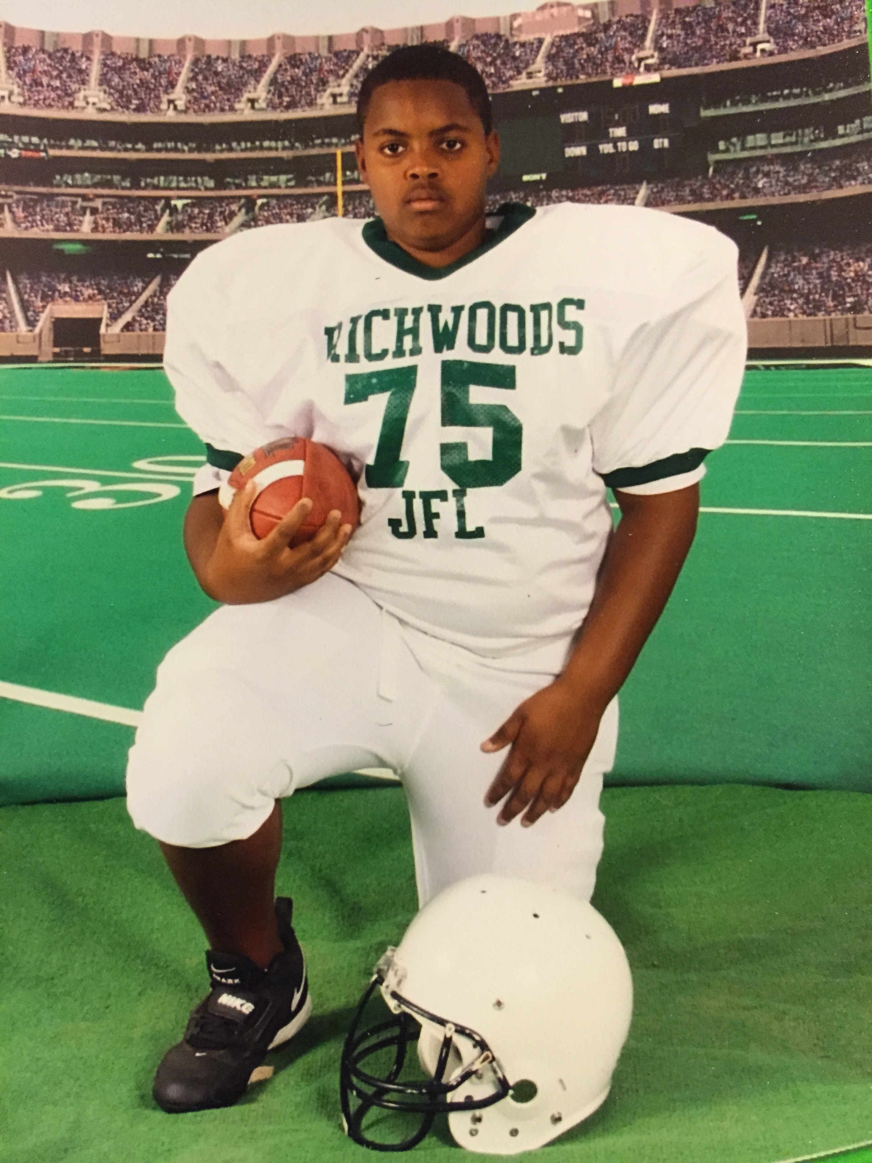
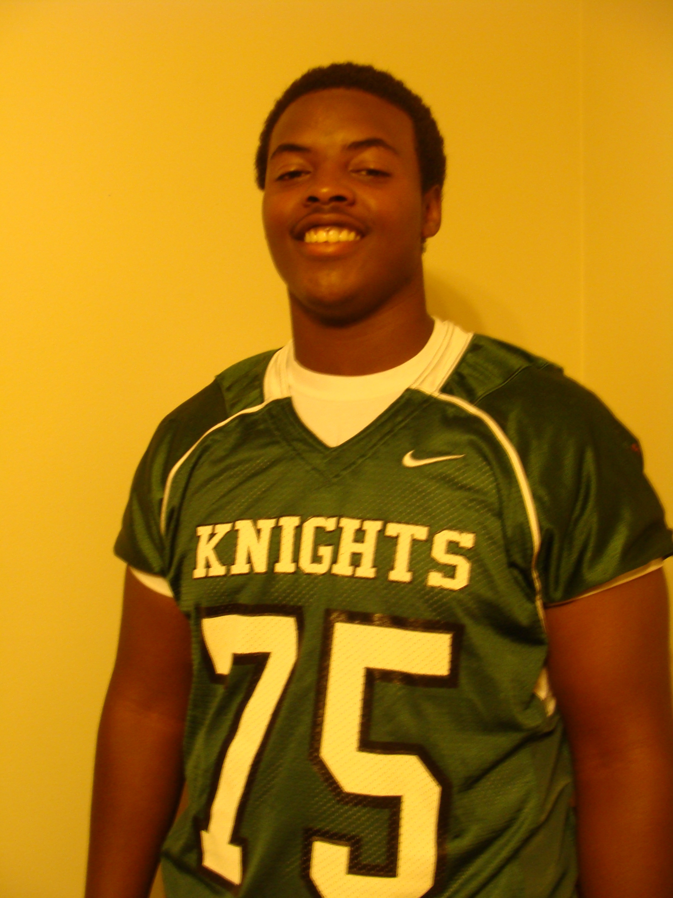
Richwoods JFL Sportsmanship and Service
Scholarship
In Memory of Deveraux Hubbard II
Richwoods JFL created this Scholarship to recognize a Graduate of Richwoods High school who displayed exemplary Sportsmanship and Service as a Richwoods High School Football Player, and who played for Richwoods JFL. This scholarship is named in memory of Deveraux Hubbard II, who was a graduate of Richwoods High School, class of 2012. He was one of the captains of the Richwoods 2011 5A State Championship-Runner Up Football Ball Team, he was an Eagle Scout, a member of National Honor Society and he played in Richwoods JFL for 6yrs. He was known for his big smile, pleasant demeanor, and his commitment to Richwoods Football. Deveraux Hubbard II was a 2nd year student at SIUC, at the time of his unexpected death due to a Pulmonary Embolism(Blood Clot) in December of 2013.

GENERAL INFORMATION AND INSTRUCTIONS FOR APPLICATION

Eligibility for this scholarship is limited to a Richwoods graduating senior who meets the following criteria:
Cumulative GPA of 2.50 or higher
A member of Richwoods Varsity Football for at least 2 seasons
Played for Richwoods JFL for at least 2 seasons
Applicants must plan to enroll at a college or university for the 2020-2021 academic year

To be considered, the application packet MUST be received via mail or email by Wednesday, October 23, 2019. Applicants must submit a completed application, (1) letter of recommendation, official high school **transcripts provided by your school in a SEALED envelope or via parchment, and an essay. Upon review of the completed application, applicants will be contacted by the Scholarship Committee, if they receive the award.

Mail to: JFL Scholarship, 6819 N. Wilshire Drive, Peoria, IL. 61614 or email: kristierhubbard@hotmail.com

Scholarship Awards will be paid upon confirmation of College/University registration ONLY! The Scholarship Award must be used within the academic year in which the award was presented or the award will be forfeited.
For questions please email: kristierhubbard@hotmail.com and in the subject line put Richwoods JFL Scholarship.

Please type or print application clearly in black ink.

SECTION I - APPLICANT INFORMATION

Name______________________________________________________________________________________________
Last First Middle
Permanent Address___________________________________________________________________________________
Street City State Zip
Phone Number (_________)_________________ Email Address_____________________________________________

Date of Birth ______/_______/_______

SECTION 2 - EDUCATIONAL INFORMATION

Cumulative GPA _______/4.0 Weighted GPA ______

Counselor’s Name______________________________________________________

Official ACT Score_____________ Official SAT score______________
** Please submit an official transcript in a SEALED envelope provided by your school or via Parchment**

SECTION 3: ACTIVITIES, INVOLVEMENT, & RECOGNITION
Please list your extra-curricular school activities, community service activities, and awards and honors
(Example: student government, athletics, orchestra, club memberships, etc.)

Extra-Curricular Activities Dates Participation/Office Held/Honors
_______________________ ____________ __________________________________
_______________________ ____________ __________________________________

Community Service Activities Dates Participation/Office Held/Honors
_______________________ ____________ __________________________________
_______________________ ____________ __________________________________

Awards & Honors Dates Participation/Office Held/Honors

_______________________ ____________ __________________________________

_______________________ ____________ __________________________________

SECTION 4: PROPOSED EDUCATIONAL PLANS
List the name and location of College/University you plan to attend:
_______________________________________________________________________________________________
List your anticipated area (s) of study:
___________________________ _________________________________ ____________________________

SECTION 5: ESSAY
Define in your own words what good Sportsmanship is, and how you have displayed Sportsmanship and Service as a Richwoods Football Player.
*Also state if you have helped with JFL since you have been in High School. If so, how?

- Essay must be 250 words or less.
- 12 or 14 Font
- Double-spaced.

SECTION 6: LETTER OF RECOMMENDATION
Please submit ONE (1) letter of recommendation from any of the following: A Coach, Teacher, Counselor, Pastor/Minister, Community Service Supervisor, Civic Leader, Employer or a friend of the family.

Applicant Signature: _____________________________________________Date: _________/____________/20 _____

